Jamie Etherington (student)

[Company name]  [Company address]

intergrated group project

# Project outline

This piece of work broadly covers the work a software engineer would undertake during the requirements gathering phase of a project, and is also a task in project management. You may also, however, be expected to call on your knowledge of software gained elsewhere on the course. You are an organization that is developing a system for a client.

The task we have been set as a group is to use all of the knowledge that we have learned during our time so far at university, to work as a team to complete the entire of a project, from planning the project, designing the solution to the clients problem, to building the system, testing and implementing our system.  
Throughout our time in education we have all developed a taste for different aspects of computing and have honed our skills around our preferences for this project.

The client we have been assigned requires us to create a calendar system. The calendar needs to be used by staff to add events to their personal diaries. A staff member should be able to add appointments on specific days at specific times, and for concrete durations. They should be able to also delete appointments from their own diary. This personal diary can be shared among other staff who accepts to share their diaries with. These are a group called Staff can view the calendar of other staff. Also, staff can make meeting requests. If they are accepted, they become part of the diary of the friends involved. Also, accepted meetings can be later rejected. The calendar can be used both on a desktop or a mobile phone.

# Interview and meeting logs

Our initial interview was set to take place on 17/02/2015. We would use this interview to ask questions and acquire further details on the project and the product that the client required us to produce.

However, the client failed to turn up. We arrived at the location in plenty of time armed with our questions to ask, but the interviewee didn’t show up. Therefore we sent him an email stating the situation and containing the questions we wanted to ask.

# Meeting log

|  |  |  |  |  |
| --- | --- | --- | --- | --- |
| Date of meeting | Names of participants | What we covered | Next objective | review |
| 17/02/2015 | * Jamie Etherington * Tom Jerrum * David Cumming * Malcom Campbel | * Views of the project * Overview of brief * Interview questions * Planned to conduct the interview | Contact client regarding rescheduling of interview, or to answer questions via email.  decide roles for the project | Productive meeting where we met each other properly for the first time. We planned out our interview and discussed initial roles. |
| 24/02/2015 | * Jamie Etherington * Tom Jerrum * David Cumming * Malcom Campbell * Mathew Donaldson | * Interview with the client * Typed up the interview transcript * Discussed and came up with our completed list of system requirements |  |  |
|  |  |  |  |  |
|  |  |  |  |  |
|  |  |  |  |  |
|  |  |  |  |  |
|  |  |  |  |  |

# Project plan

To successfully complete this project we need to assign jobs, and plan our time effectively to control and monitor the progress of the tasks.

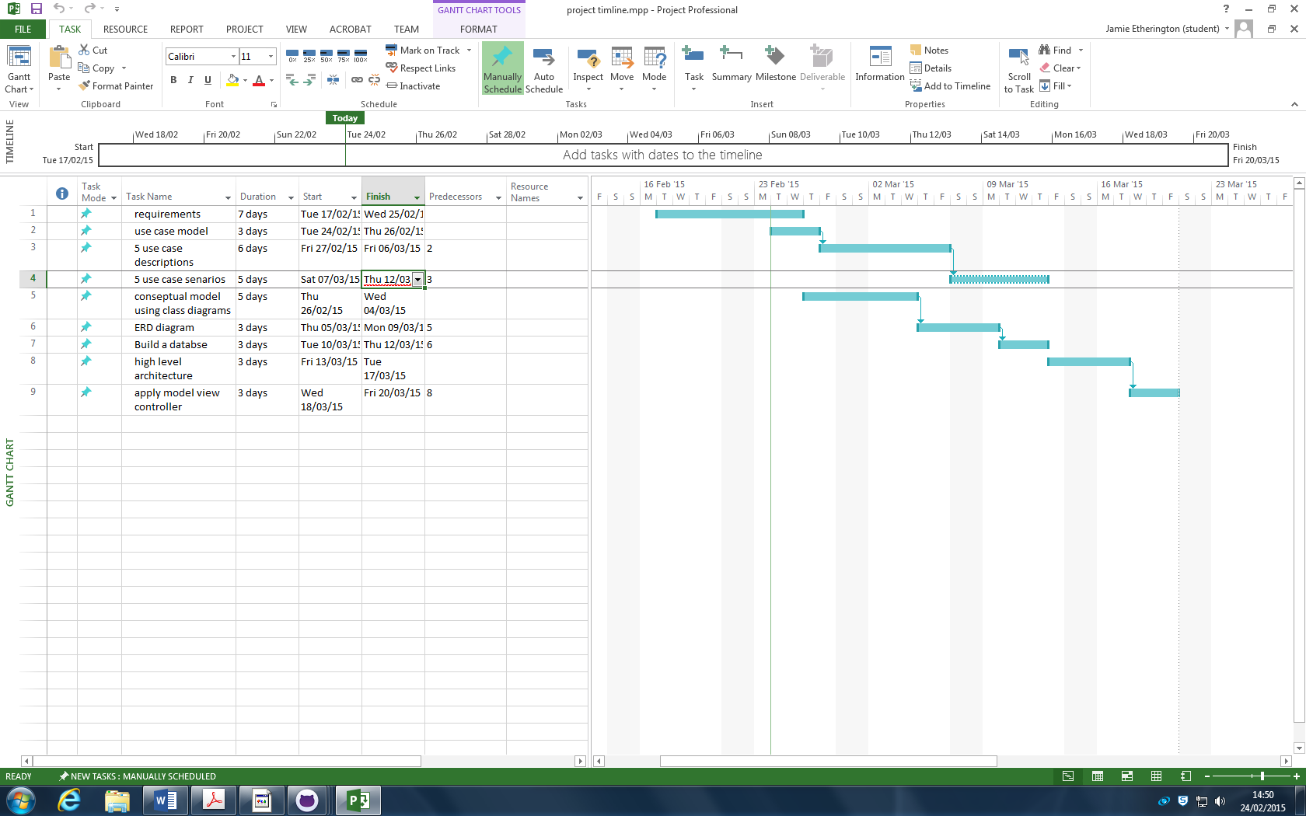

# Project roles

1. Project Leader (ensures tasks are on time, allocates tasks, organizes meetings, )   
   Jamie Etherington, Tom Jerrum
2. Technical Leader (Ensures that members have the technical information, coordinates that knowledge is shared among members, )   
   Malcolm Campbell
3. Quality Assurance Leader (that the artefacts produced satisfy project tasks)

Mathew Donaldson

1. Configuration Manager (ensures documents are up to date, integrates works of others, responsible for delivering group work)

David Cumming

# System requirements

From our initial case study we have come to the conclusion that there are a number of initial requirements that the client needs to be implemented in the system. These initial requirements have given us a brief introduction into what we need to undertake as a project, and has also highlighted further questions we need to ask in our first interview with the customer.

## Initial requirements

* The system to be produced is a calendar
* The calendar needs to be used by staff to add events to their personal diaries.
* A staff member should be able to add appointments on specific days at specific times
* The appointments need to have durations applied
* They should be able to also delete appointments from their own diary.
* This personal diary can be shared among other staff who accepts to share their diaries with.
* These are a group called Staff can view the calendar of other staff.
* staff can make meeting requests.
* If they are accepted, they become part of the diary of the friends involved.
* accepted meetings can be later rejected.
* The calendar can be used both on a desktop or a mobile phone.

## Interview questions and answers

* Would the system require a log on, using your existing university log on information?
  + The client would like new log on details as opposed to using the existing university log on and password
* How would you like the calendar to be formatted?
  + Daily, weekly, monthly, choice of the above

The client would like to be able to select from multiple views to view their diary in more detail.

* + Choice of only showing the appointments

the client also wanted to be ab le to only see the appointments made as oppose to all the free dates

* Would you like any special design features?
  + Colour coded events?
  + Appointments at different locations in different colour’s?

There are no specific design requirements as long as the functionality of the system is not compromised.

* How often do you use your current time keeping method?

At current there is no existing system for keeping track of appointments.

* Any interface specific requirements?
  + Font sizes, styles, images included or only text

There are no given requirements on styling the system as long as system is legible and easy to understand.

* Will the program need to run simultaneously for multiple users?
  + Yes, the client stated 7 users should be able to use the system simultaneously without the system being effected.
* How would you like the appointment requests to be displayed
  + Pop up
  + Notification

The user should be alerted to meeting requests and upcoming appointments in a notification bar much like the one used on social media sites such as facebook

* What sort of budget are we working with?

There is no specific budget requirements however we should work efficiently and as resourcefully as possible

* What are the time restraints and deadlines the project needs to be completed by?

Phase one of the system (the design and planning) must be completed by the 23rd of march, and the second phase (implementing and testing the system) should be completed by the end of may

* Any information about the database you require?

The database needs to hold the information on appointments and other staffs bookings. This would allow the app to look at past appointments and to see other clients appointments

* Would the application be locally based or accessed of a website?

The calendar needs to be displayed in app, and source its information and data from a web server connected to the database that contains the information regarding appointments and bookings.

## Completed System Requirements

### Functional requirements

* The system to be produced is a calendar
* The calendar needs to be used by staff to add events to their personal diaries.
* A staff member should be able to add appointments on specific days at specific times
* The appointments need to have durations applied
* They should be able to also delete appointments from their own diary.
* The personal diary can be shared among other users who allow access.
* Users can make meeting requests with other users.
* If they are accepted, they become part of the diary of the friends involved.
* Accepted meetings can be later rejected.
* The calendar can be used both on a desktop or a mobile phone.
* The system requires new log on information fort the users
* The user should be able to change the view of the calendar from 3 different views; daily, weekly and monthly. There should be a way for the user to only view their appointments
* The system needs to be legible and information should be easy to access
* The system should be have the capacity to be used by multiple users at once
* Alerts regarding upcoming appointments and meeting requests need to be shown in a notification bar, similar to Facebook
* Phase one of the system (the design and planning) must be completed by the 27th of march, and the second phase (implementing and testing the system) should be completed by the end of may
* The appointment data needs to be held in a database
* Users should be able to view past appointments as well as future meetings
* The calendar needs to be displayed in app, and source its information and data from a web server connected to the database that contains the information regarding appointments and bookings.

### Non-functional requirements

* The system should take into account accessibility; in particular those who struggle with colour blindness. This means that the colours used on the system such as background/foreground colour combinations should be clear and not risk having information lost in translation.
* The system should be backed up. the database that hold the personal calendar data should not only be held on the web server, but should also be backed up offline to prevent total system corruption.
* The system needs to be accompanied by a set of user documentation to help the new users with any issues they have. Seeing as the client has no current system similar to ours, the processes and methods of using the system should be documented to aid in training the users.

# Use Case model

# ERD Diagram

The ERD diagram below is used to show the relationships between the tables and attributes that will be contained within our systems database. This shows how the tables tUser, tEvents and tLocation will be linked, with each data type for each attribute, and the relationship type between the foreign and primary keys

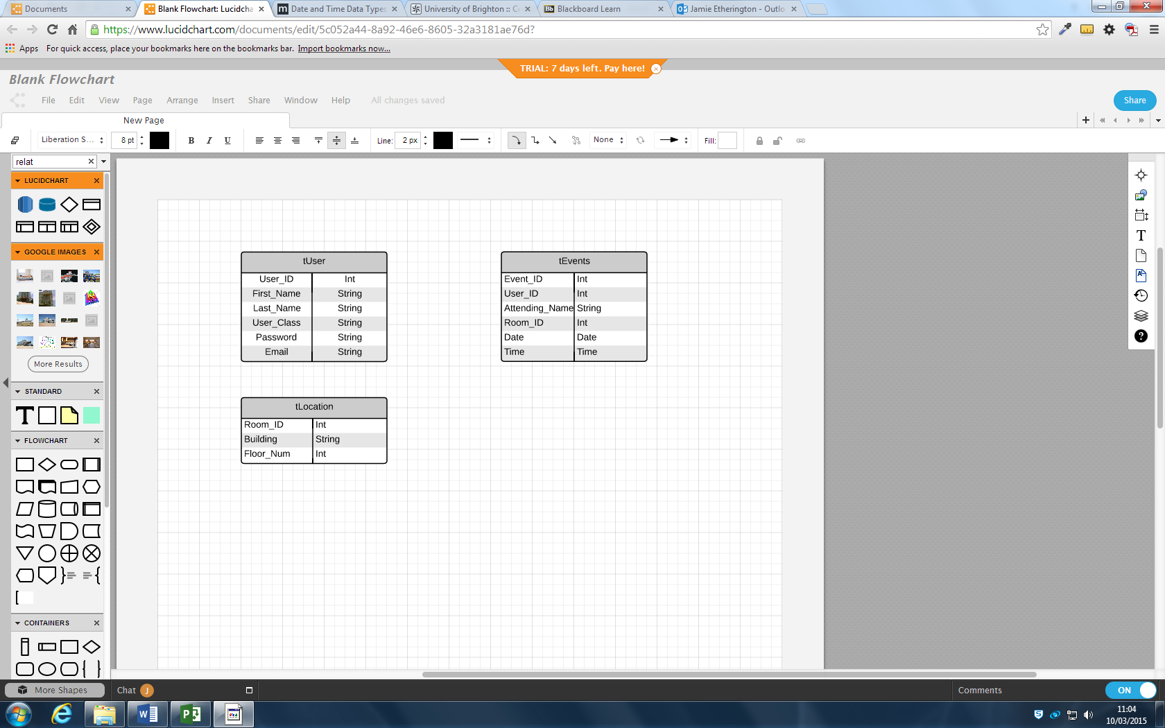

Foreign Key

Event location

Event Creator

Primary Key